Program 1

firstname=input("enter your first name:")

lastname=input("enter your last name:")

print(f"greeting!!{firstname}{lastname}")



program 2

a=5

b=3.5

c=2.08j

print("type of a is:",type(a))

print("type of b is:",type(b))

print("type of c is:",type(c))



program 3

pi=3.14

r=int(input("enter the radius:"))

Area=pi*r*r

print(f"the area of the circle is{Area}")



program 4

basic_salary=int(input("enter the basic salary of employee"))

HRA=10*basic_salary/100

TA=5*basic_salary/100

total_salary=basic_salary+HRA+TA

print("total salary is:",total_salary)

p

program 5

a=int(input("enter the first number:"))

b=int(input("enter the second number:"))

sum=a+b

difference=a-b

product=a*b

div=a/b

mod=a%b

print(f"the sum is{sum}the product is{product}difference is{difference}the modu>



program 6

orginal_string=input("enter a string:")

n=int(input("enter a non negative integer"))

if n>=0:

result=orginal_string*n

print(f"the result is:{result}")

else:

print("plz enter non negative int")



program 7

n=input("enter the num:")

print(n,'+',n*2,'+',n*3)

sum=int(n)+int(n*2)+int(n*3)

print(sum)

p

program 8

a=5

b=4

c=8

if a>b and a>c:

print("a is the largest")

elif b>a and b>c:

print("b is the largest")

else:

print("c is the largest")

p

program 9

year=int(input("enter the year"))

if year%400==0:

print("it is a leap year")

elif year%100==0:

print("it is not a leap year")

elif year%4==0:

print("it is a leap year")

else:

print("it is not a leap year")

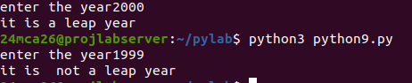

program 10

age=int(input("enter the age"))

if age<10:

print("ticket rate is 7")

elif 10<=age<60:

print("ticket rate is 10")

elif age>60:

print("ticket rate is 5")

else:

print("invalid entry")

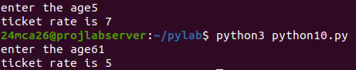u

program 11

import math

print("quadratic eqn ax^2+bx+c")

a=float(int(input()))

b=float(int(input()))

c=float(int(input()))

d=(b*b)-(4*a*c)

if(d==0):

print("only one root value\n")

ans=(-b)/(2*a)

print("x= ",ans)

elif(d>0):

sqrtvalue=math.sqrt(d)

ansone=(-b+sqrtvalue)/2*a

anstwo=(-b-sqrtvalue)/2*a

print("x1= ",ansone)

print("x2= ",anstwo)

else:

print("complexroot")

sqrtvalue=math.sqrt(abs(d))/(2*a)

print(-b/(2*a),"+i",sqrtvalue)

print(-b/(2*a),"-i",sqrtvalue)

